Year 7 Higher Learn By Heart
January Assessment.
Extending your knowledge of year 7 Maths!
Top Tips:
- Use look, cover, write, check to learn the facts.
- Get someone to read the facts pausing at the bold words, do you know what comes next?
- Use a blank grid and see how much you can fill out with only the pictures to give you hints
- Make up questions to test yourself or get someone to test you on the facts.
- Once you know the facts, try to apply your knowledge using revision questions or Sparx.

Higher Learn By Heart: Sequences
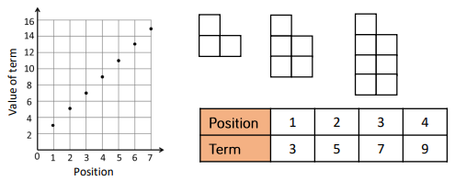 | A sequence can be recorded into a table.
 | A linear sequence makes a straight line when plotted on a graph.
+ 6  6 $÷$ 3 = 2  Rule = Add 2 | To find missing values in a sequence, work out the overall difference and use this to find the term to term rule.

Higher Learn By Heart: Equality and Equivalence
$$≡$$ | Equivalent expressions have the same value when any number is substituted in. In maths we call this an identity and use a $≡$ sign.
 | When collecting like terms, we are creating a simpler equivalent expression.
$$x$$ | A variable is a letter in an algebraic expression.
3 a² | A coefficient is the number in front of the variable.
Higher Learn By Heart: Algebraic Notation
‘n’th | Position is the place in the sequence
5n + 6 | A position-to-term rule or algebraic rule explains how to work out the term given the position.  e.g. x 5 then add 6  It is also known as the ‘nth term’ where ‘n’ is the position number in the sequence.
5 (2) + 6 | To find a term in a sequence given an algebraic rule, substitute the position number into the rule.  e.g. 5 x 2 + 6 would give the 2nd term
y = 3x + 6 | When graphing a function, the x values are the input and the y values are the output.
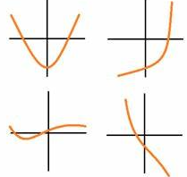 | A function with a power of x or x as a denominator will be a non-linear function.  e.g. y = $3x^{2 }+5x$  y = $\frac{5}{x}$

Higher Learn By Heart: Place Value
$${10}^{y}$$ | Powers of ten tell you how many times to multiply by 10.  e.g. ${10}^{4}=10×10×10×10=10000$
 | Standard form is a way to write very big or very small numbers using powers of 10
$$x ×{10}^{y}$$ | A number in standard form must start with a number between 1 and 10 ($1≤x<10).$
$$51×{10}^{2}$$  $$5.1 ×{10}^{3}$$ | When calculating with standard form, remember to check your final answer is in standard form.

Y7 Higher Learn By Heart: Fractions, Decimals and Percentages
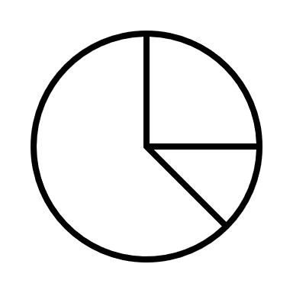 | Pie Charts represent proportion of a whole.  Angles to remember:  90⁰ = $\frac{1}{4}$ of the data 180⁰ = $\frac{1}{2}$ of the data  60⁰ = $\frac{1}{6}$ of the data 45⁰ = $\frac{1}{8}$ of the data
 | On a number line, each section represents an equal part, the same as an equal part of a fraction.
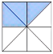  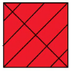 | When representing fractions in diagrams, each section must be an equal size.
> 1 | Fractions, decimals and percentages can all be above one.  e.g. $\frac{13}{10}$ = 1.3 = 130%

