**Year 8 Spanish DC1 Learn Sheet – Key Spanish vocabulary**

Las instalaciones – School buildings

la clase – classroom

la biblioteca – library

el patio – courtyard

los laboratorios – science classrooms

el comedor – dining hall

la piscina – swimming pool

el campo de fútbol – football pitch

el gimnasio – gym

Todo sobre yo – All about me

Me llamo – My name is

Soy – I am

Tengo (trece) años – I am (13) years old

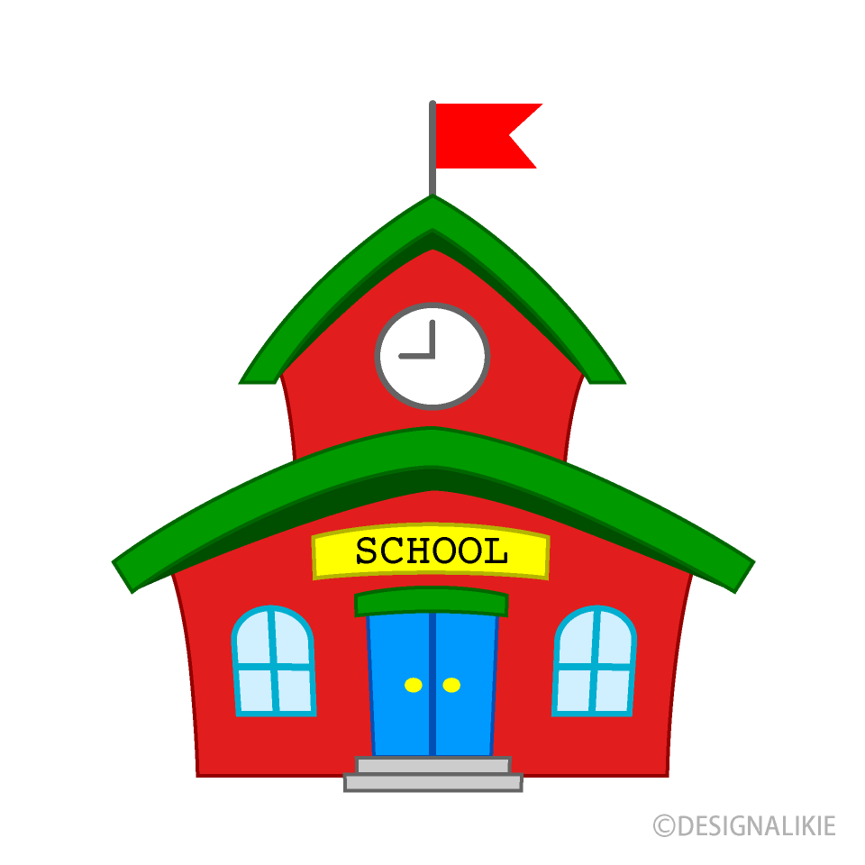

Su aspecto – His/Her appearance

Tiene los *ojos azules* – He/she has blue eyes

Tiene el pelo *rubio, rizado y largo* – He/she has blonde, curly, long hair

Es alto/a/@ - He/ She is tall

No es delgado/a/@ – He / she is not slim

Lleva gafas – He / she wears glasses

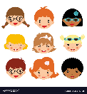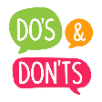

La comida – food

una chocolatina – a chocolate bar

un bocadillo – a sandwich

agua – water

caramelos - sweets

Los deportes – Sports

Juego al – I play

fútbol – football

rugby – rugby

voleibol – volleyball

tenis – tennis

baloncesto – basketball

Hago – I do

natación – swimming

equitación – horse riding

artes marciales – martial arts

atletismo - athletics

Días de la semana – Days of the week

Lunes – Monday

Martes – Tuesday

Miércoles – Wednesday

Jueves – Thursday

Viernes – Friday

Sábado – Saturday

Domingo – Sunday

Remember to add “los” to say “on” (For example: Los lunes – On Mondays.)

Las normas del insti – School rules

(no) se debe – you must (not)

correr en los pasillos – run in the halls

ser punctual – be on time

comer chicle – chew gum

ser agresivo o grosero – be aggressive or rude

llevar uniforme/piercings – wear uniform/piercings

usar el móvil en clase – use your phone in class

salir del insti durante el día – leave school during the day

¡qué injusto! – how unfair!

Las asignaturas – School subjects

el español – Spanish

el inglés – English

el francés - french

el dibujo – art

el teatro – drama

la historia – history

la educación física – PE

las ciencias – science

las matemáticas - maths

**Year 8 Spanish DC1 Learn Sheet - Spanish Grammar**

Key times

A las diez – at 10 o’clock

A las nueve y media – at 9:30

Me lavo los dientes – I brush my teeth

Present tense Key words

Tengo – I have

Hago – I do

juego – I play

estudio – I study

Vivo en – I live in

como – I eat

bebo – I drink

The comparative

más …. que – more than

(*La casa es más moderna que el piso*)

menos … que – less than

(*El dibujo es menos aburrida que el inglés*)

Future tense key words

me gustaría – I would like

Sería – it would be

**Positive adjectives**

útil – useful

fácil – easy

entretenido – entertaining

divertido – fun

emocionante – exciting

bonito – pretty

amplio – spacious

grande – big

cómodo - comfortable

**Negative adjectives**

difícil – difficult

aburrido – boring

inútil - useless

feo – ugly

pequeño – small

antiguo – old

raro – strange

severo – strict

ruidoso – noisy

**Opinions**

me gusta – I like it

no me gusta (nada) – I do not like it (at all)

me gusta mucho – I really like it

me encanta – I love it

odio – I hate it

Prefiero – I prefer

**Opinion Phrases**

En mi opinión – In my opinion

Pienso que – I think that

Encuentro que – I find that

Creo que – I believe that

Intensifiers

bastante – quite

muy – very

un poco – a little

súper – really

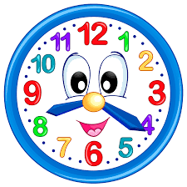

Past tense key eords

fui – I went

era – it was

había – there was

3rd Person Key Verbs

hay – there is

es – it is

tiene – it has

son – there are

estudiamos – We study

tenemos – we have

vivimos – we live

Time Phrases

por la mañana – in the morning

por la tarde – in the afternoon

En el futuro – In the future

Mañana – tomorrow a veces - somtimes

Top tips for perfect Spanish grammar

1. Make sure any adjectives come after the noun they are describing. (For example: Tengo un **perro blanco** – I have a white dog)
2. Make sure when you use adjectives to describe people, the ending of the word agrees with the gender of who it is describing. (For example: **Mi hermano es divertido y mi hermana es simpática** – My brother is fun and my sister is kind)
3. Remember to use the correct verb when talking about sports, some sports use “**juego al** – I play” and some sports use “**hago** – I do”.
4. When you are comparing two things (for example, saying something is bigger than something else, or more interesting than another thing) you must use **the comparative**. You need to use “**más**” and “**que**” to say more than. For example, “**La casa es más grande que el piso** – the house is bigger than the flat.”
5. When you are talking about things you would like, in the future, you must use the future tense. You can recognize it by the “**ía**” at the end of verbs. To form the future tense, keep the verb you want in the infinitive, and add “**ía**” at the end. For example, **vivr** = to live, **viviría** = I would like to live.
6. There are two examples of verbs that do not follow the normal pattern for creating the future tense. “**Tendría** – It would have and **Habría** – there would be”

Connectives

pero – but

y – and

o – or

sin embargo – however

además - moreover

porque - because