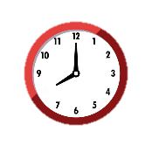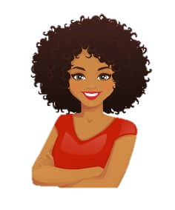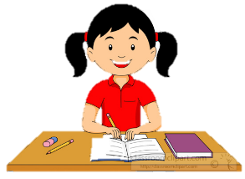**Year** **8** **French DC1 Learn** **Sheet** – **Key** **French** **vocabulary**

Les règles scolaires – School rules

On doit… - You must…

porter l’uniforme – wear uniform.

arriver à l’heure – arrive on time.

Il est interdit de… It’s forbidden to…

mâcher du chewing gum – chew gum.

utiliser les portables – use phones.

Positive Adjectives – Positive adjectives

Amusant - Fun

Intéressant - Interesting

Drôle / Marrant - Funny

Facile - Easy

Préféré – Favourite

Sympa – Nice

Chouette – Great

Gentil - kind

Révisions Y7 – Y7 revision

il a/elle a – he has/she has

les cheveux courts / longs – short/long hair

les cheveux frisés/raides – curly/straight hair

les cheveux bruns/noirs/blonds –brown/black/blonde hair

les yeux bleus/verts/marron – blue/green/brown eyes

L’heure – The time

à huit heures (à 8h) – at 8 o’clock

à midi – at 12 noon

à treize heures – at 13 :00 (=1pm)

à neuf heures et demie – at 9:30

à dix heures et quart – at 10:15

à onze heures moins le quart – at 10:45

on commence à – we start at…

on finit à – we finish at….

Miscellaneous

la batterie – drum kit

les jeux vidéos – video games

voyager – to travel

l’hard rock – hard rock (music)

mon ordinateur – my computer

bavarder – to chat

La nourriture – Food

Des hamburgers - Burgers

Des frites - Chips

Du poisson - Fish

Du poulet - Chicken

Negative Adjectives – Negative adjectives

Barbant - Boring

Ennuyeux - Boring

Nul - Rubbish

Difficile - Difficult

Sévère - Strict

Les jours de la semaine –

The days of the week

Lundi - Monday

Mardi - Tuesday

Mercredi - Wednesday

Jeudi - Thursday

Vendredi - Friday

Samedi - Saturday

Dimanche - Sunday

Les matières – School subjects

Les cours – The lessons

La technologie – technology

Les arts plastiques – art

Les sciences - science

L’anglais – English

Le français – French

Le théàtre – drama

La musique – music

L’informatique - IT

La géographie – geography

L’EPS – PE

L’histoire - history

L’école – School

La récréation – break

La pause déjeuner – lunch time

Un cours – a lesson

Les devoirs – homework

manger à la cantine – to eat at the canteen

la piscine – the swimming pool

L’uniforme scolaire - School Uniform

Je porte… – I wear…

un pantalon noir – black trousers

une cravate – a tie

une veste – a jacket

des chaussures – shoes

une chemise blanche – a white shirt

un pull – a jumper

Je voudrais porter – I would like to wear

Mes propres vêtements – my own clothes

Un jogging – joggers

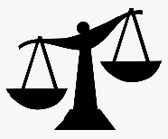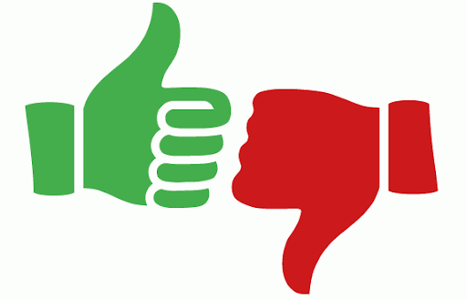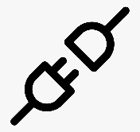**Year** **8** **French DC1 Learn** **Sheet** - **French** **Grammar**

Frequency Phrases

Quelquefois Sometimes Le soir - In the evening

Tous les jours Every day Le matin – In the morning

Tout le temps All the time Normalement - Normally

De temps en temps From time to time

Comparatives

**plus + adjective + que = more… than…**

**moins + adjective + que = less… than…**

e.g. plus intelligent que – more intelligent than

**Top tips for perfect French grammar**

1. Make sure any adjectives come after the noun they are describing. (For example: Je porte **un pull vert** – I wear a green jumper).
2. Make sure when you use adjectives to describe people, lessons or clothes, the ending of the adjectives agrees with the gender of what it is describing. (For example: **L’anglais est amusant mais la technologie n’est pas amusante** – English is fun but tech isn’t fun).
3. To talk about more than one of something (two bedrooms, three teachers etc.) you must add an “s” to the end of the word. (For example: **Dans ma maison, il y a trois chambres et deux salles de bains** – In my house there are three bedrooms and two bathrooms).
4. Remember to vary your adjectives and your opinions when you write a piece of writing. The more varied your vocabulary is, the better!
5. Make sure that you use plenty of connectives and intensifiers.
6. Always take time at the end of your test to read through all your work again, so you can double-check your adjective endings and your verbs. It is very important!

Connectives

mais – but

et – and

ou – or

cependant – however

car - because

aussi - also

Important verbs

Je m’appelle – My name is

Je suis – I am

J’ai – I have

J’ai ____ ans – I am ___ years old.

J’habite à (+town) – I live in…

J’habite en Angleterre – I live in England.

Je vais – I go

Je voudrais étudier – I would like to study

Je porte – I wear

C’est – it is / Ce n’est pas – it is not

Il y a – there is/there are

Il n’y a pas de – there is no/there are no

Negatives in French

In French to make a verb negative, you just need to add “ne” and “pas” around the verb.

Je suis – I am Je **ne** suis **pas** – I am not

Je suis – I am Je **ne** suis **jamais** – I am never

Opinions

J’aime – I like

Je n’aime pas – I do not like

J’aime beaucoup – I really like

J’adore – I love

Je déteste – I hate

Opinion Phrases

A mon avis – In my opinion

Je pense que – I think that

Je crois que - I believe that

Pour moi – For me

Intensifiers

assez – quite

très – very

un peu – a little

vraiment – really