Year 8 Higher Learn By Heart
January Assessment
Extending your knowledge of year 8 Maths!
Top Tips:
- Use look, cover, write, check to learn the facts.
- Get someone to read the facts pausing at the bold words, do you know what comes next?
- Use a blank grid and see how much you can fill out with only the pictures to give you hints
- Make up questions to test yourself or get someone to test you on the facts.
- Once you know the facts, try to apply your knowledge using revision questions or Sparx.

Higher Learn By Heart: Ratio
1 : □ | To compare ratios it is useful to write them in the form 1:n or n:1.  When using this form, n can be any number including a fraction or decimal.
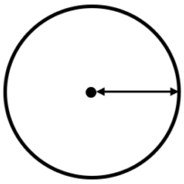 | The radius is the distance from the centre to the edge of a circle
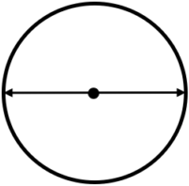 | The diameter is the distance all the way across a circle through the centre
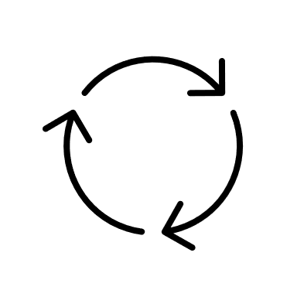 | The circumference is the distance all the way around the edge of the circle
π | The symbol π is called pi and represents the irrational (never-ending) number 3.14159…
C = | The ratio of the diameter to the circumference of the circle is always 1: π so C = π x d.
Gradient tells us how steep a line is.

It is the ratio of the base to the height of a triangle drawn under the line.
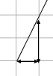 | To find the gradient work out how many squares you go up for every one you go across using $\frac{height}{base}$

Higher Learn By Heart: Multiplicative Change
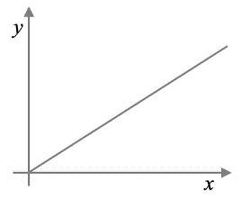 | A direct proportion graph must start at (0,0) and be a straight line.
$$1:100000$$  $$1cm :100000cm$$  1cm : 1000m  1cm : 1km | A map scale needs to show large distances.  Common scales are 1:50000 and 1:25000.  No units are given so use the same units on both sides then convert the real-life side to a more sensible unit.
When working with similar shapes we use scale factors to show what we multiply the lengths by.
If moving from a larger shape to a smaller shape the scale factor will be a fraction or decimal less than 1
Higher Learn By Heart: Multiplying and Dividing Fractions
$$1\frac{1}{2}×2\frac{1}{5}$$  $$\frac{3}{2}×\frac{11}{5}$$ | To multiply or divide mixed numbers – change to improper fractions first.  Don’t forget to change your answer back into a mixed number.
4t | Multiplication signs are not used in algebra:  4 x t = 4t  t x t = t²
$$\frac{2x}{5}$$ | Division in algebra is written as a fraction
$$\frac{x}{2}÷\frac{x}{5}$$ | For algebraic fractions, you just use all the same methods as numerical fractions.
Higher Learn By Heart: Cartesian Plane
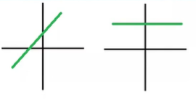 | A linear graph makes a straight line when plotted.
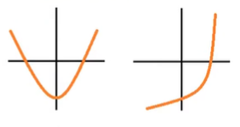 | A non-linear graph does not make a straight line when plotted.
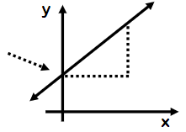 | A linear graph has an equation of the form  $y=mx+c$  The $m$ is the gradient, it tells us how steep the line is (check unit 1 LBH)  The $c$ is the $y$ -intercept, it tells you where the graph crosses the $y$ axis.
Higher Learn By Heart: Representing Data
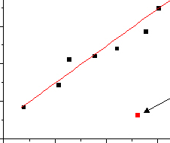 | An outlier is a point that is far away from the other points and does not fit the pattern of correlation, suggested by the other points.
 | The line of best fit should only be used for predicting the second value if the value of the first variable lies within the data range of the scatter graph. This is known as interpolation.
 | If the value of the first variable lies outside the data range given by the scatter graph, then using the line of best fit for predicting the value of the second variable is unreliable. This is known as extrapolation.
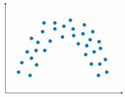 | In non-linear correlation, there is a relationship between the 2 variables but it’s just not linear. Therefore, we would not be able to draw a straight line of best fit.
Higher Learn By Heart: Probability
ξ | The ξ symbol represents the universal set. This contains all the values of the set.
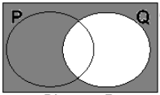 | The set Q’, is the list of all the values or numbers outside Q.  It is called the complement of Q.
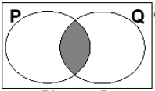 | P ∩ Q means write the values or numbers which overlap or are common to both P and Q.  It is called the intersection of P and Q.
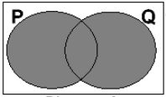 | P U Q means write all the values or numbers which are in P or Q or both.  It is called the union of P and Q.
m x n | If there are m options for a first choice and n options for a second choice, then there are  m x n combinations created when making both choices.  This is called the product rule for counting.
a x b x c x… | The product rule can be extended to 3 or more things to select.  e.g if there are 3 starters, 4 main courses and 2 desserts to choose from, in total there are  $3 × 4 × 2 = 24$ possible meal choices.

Higher Learn By Heart: Sequences
5n + 6 = ? | To decide if a number is in a sequence, set up and solve and equation with  ‘n’th term = number.  If there is an integer answer for n then the number is in the sequence (at position n).

Core Learn By Heart: Brackets, Equations and Inequalities
FOIL | When expanding double brackets such as (y + 10)(y + 3) we can use the  FOIL method: First, Outer, Inner, Last
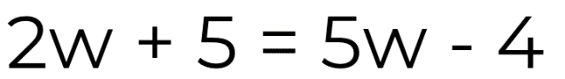 | When an equation has variables on both sides the first step is to eliminate the variable with the lowest co-efficient
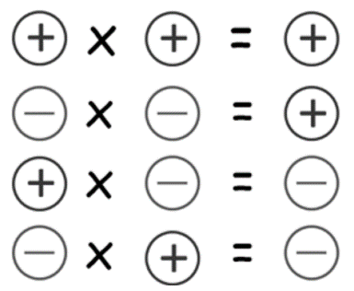 | If we multiply or divide a positive number and a negative number the answer will be negative.  If we multiple or divide two negative numbers the answer will be positive.

